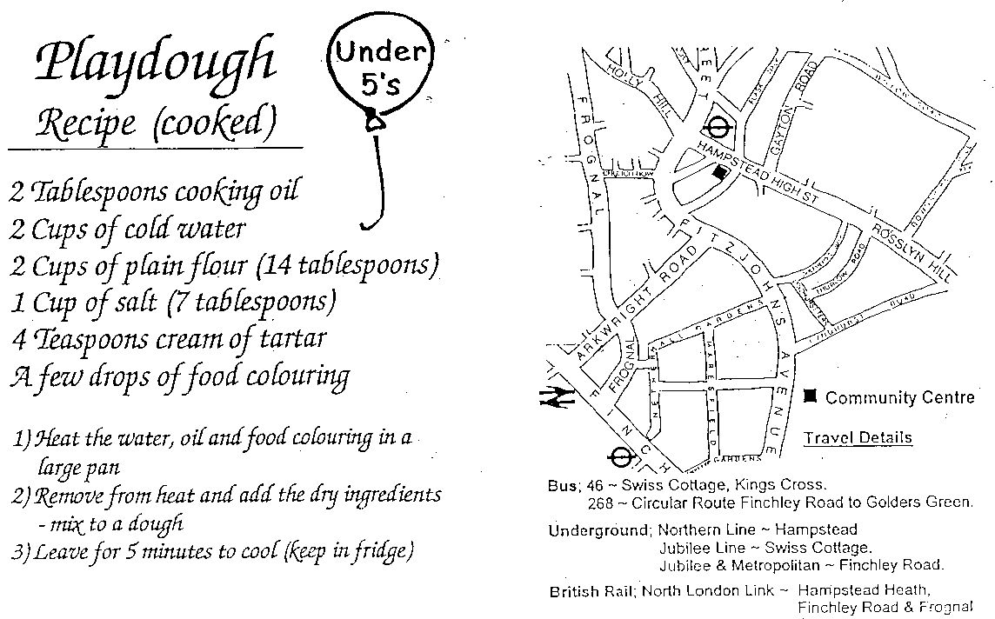

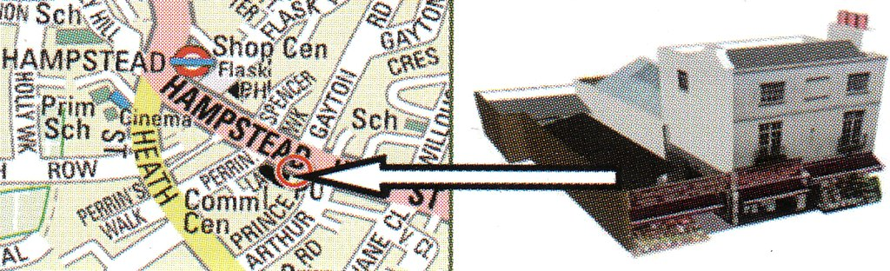

Tube: Hampstead Northern Line

Buses: 46, 268

**Hampstead Community Centre**

78 Hampstead High Street London NW3 1RE

020 7794 8313 hampsteadcommunitycentre@btconnect.com

www.hampsteadcommunitycentre.co.uk

Reg. Charity 282089

**under 5s**

**Term time drop-in sessions**



**Summer Term 2024**

The under 5’s drop-in aims to provide a safe and stimulating environment for young children to play, have fun and develop both social and physical skills.

It is also a place where parents/carers are able to get together to share ideas and experiences and get help and information in a relaxed and friendly atmosphere.

Each session has a particular theme, and parents/carers are encouraged to participate.

For more information please call on the above number

or pop in and see us

# **http://share.scope.org.uk/sites/default/files/imagecache/icon_250x250/1019_musical_note_red_0.pngUnder 5’s drop-in sessions**

UNDER 5'S ACTIVITIES

# **Tuesday 9.30-12.00**

**Music & Rhyme time**

# **Wednesday 9.30-12.00**

## **http://i3.squidoocdn.com/resize/squidoo_images/400/draft_lens17688988module148552673photo_1298827206cherry-cup-cake-clipart.jArt Activities**

# **Thursday 9.30-12.00**

## **Toddler Cookery**

******Friday 9.30-12.00** **+**

**Music & Art**

**£3.00 per child per session on Tuesday, Wednesday and Friday £5.00 per child on Thursday (cooking day) Concessions available**

**Play activities include:**

Play dough, imaginative play, puzzles & books, dolls, dressing-up, construction toys, climbing frame, slide, bikes etc. available every day.

There is always a soft play area and baby toys.

**Help yourself to tea, coffee and biscuits, while your child has a healthy snack – included in the price.**

We have an informal system of tidying and would be grateful if you could help when possible.

**You remain responsible for your child/children and**

**their behaviour at all times.**

**For the safety of all children, please make sure that the door is properly closed behind you every time you enter or leave.**

Donations of unwanted toys, art materials etc. greatly appreciated! Thank you!

#### http://share.scope.org.uk/sites/default/files/imagecache/icon_250x250/1019_musical_note_red_0.pnghttp://share.scope.org.uk/sites/default/files/imagecache/icon_250x250/1019_musical_note_red_0.pngMusic and Rhyme time

**Every Tuesday**

**Come and join in with song, dance, parachute games, bubbles**

**and musical instruments.\***

**Wednesday’s Art Projects**

**17/04 Finger painting 05/06 Painting fish**

**24/04 Dinosaur (plate) 12/06 Father’s Day cards**

**01/05 Flowers on a stick 19/06 Vegetable printing**

**08/05 Matching shapes 26/06 House pictures**

**15/05 Sponge printing 03/07 Butterfly pictures**

**22/05 Collage hot air balloon 10/07 Pasta Necklaces**

**17/07 Rice Pictures**

## **The Under 5’s drop in will be closed for the**

**Half term 27th – 31st May 2024**

**Toddler Cookery Every Thursday**

**Come and have fun trying out some simple cooking with your toddler.**

**We use simple recipes for things such as pizza, scones, cheese straws and biscuits etc.**

**18/04 Cheese and herb biscuits 06/06 Cinnamon swirls**

**25/04 Coconut biscuits 13/06 Garlic bread**

**02/05 Pizza 20/06 Empanadas**

**09/05 Apple turnovers 27/06 Jam tarts**

**16/05 Garlic bread 04/07 Tomato swirls**

**23/05 Cinamon swirls 11/07 Short bread sprinkles**

**18/07 Pizza**

**Friday Music and Art**

**There will be a seasonal art project**

**followed by music, instruments and bubbles**

**Summer party Friday 19th July**

**Monetary contributions or donations of food & drinks greatly appreciated.**